APPENDIX

Figure For Passive Mode  


|  |  |  |  |
| --- | --- | --- | --- |
| **Feature** | **Device A**  **(Over-ear Headphone)** | **Device B**  **(Close-fitting Earbud)** | **Device C**  **(Open-fitting Earbud)** |
| **Attenuation Pattern** | Significant attenuation from 200 Hz, up to -30 dB above 10kHz | Minimal low frequency attenuation (flat to 200 Hz), steep drop-off above 500 Hz, reaching ~ -30dB above 10kHz | Similar to B, but less attenuation depth reaching ~ -15dB above 10kHz |
| **Consistency across fit** | **Highly sensitive to placement**. Significant inconsistencies across SPLs, especially below 300 Hz and above 5 kHz, due to fit variations. | Robust. Nearly identical performance across all SPLs, indicating **consistent acoustic seal** regardless of minor insertion depth variations. | Robust. Stable seal with **minor deviation at high frequencies** (>8 kHz), resilient to fit variations. |
| **Observation** | **Inconsistent seal** makes passive attenuation varies, directly tied to wearing method. | **Good for passive isolation**. Stability against varied fittings provides a reliable platform for ANC. | Despite "open-fitting" label, acts as a **semi-occluding earbud**. Offers good, stable passive isolation resilient to placement changes. |

TIME-VARYING ANALYSIS - DEVICE C





Aircraft Simulation Psychoacoustic

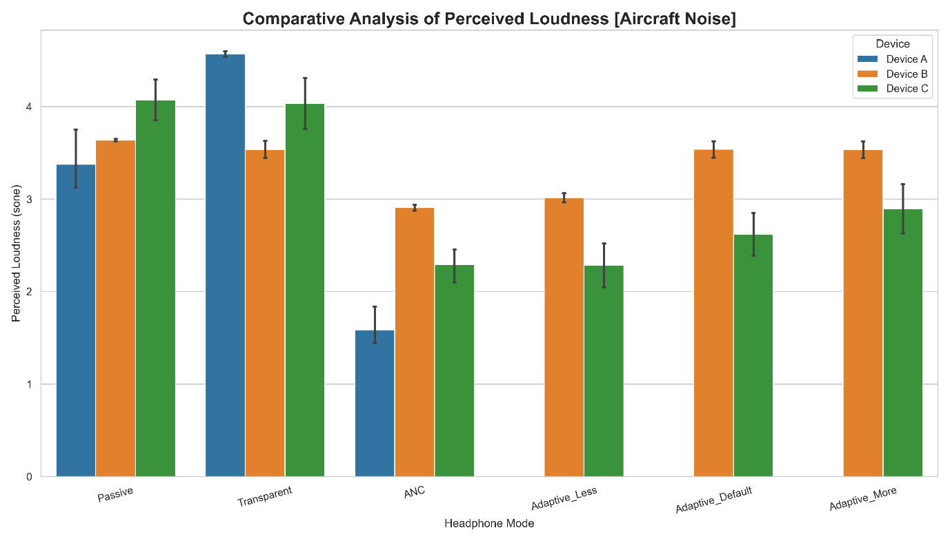

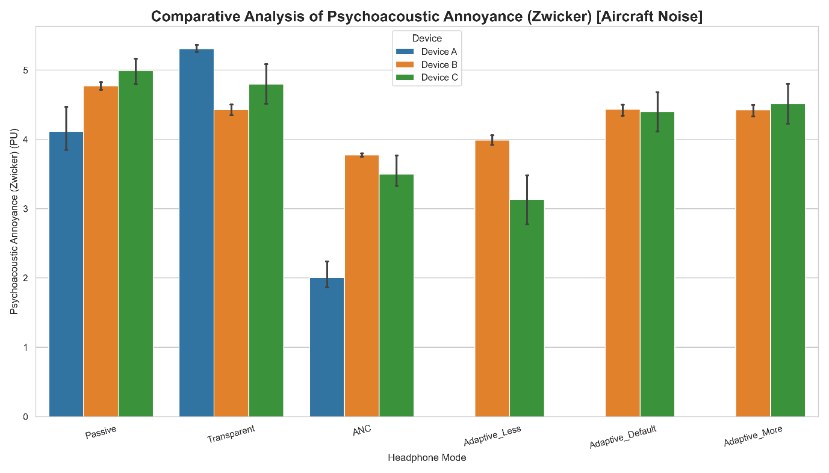

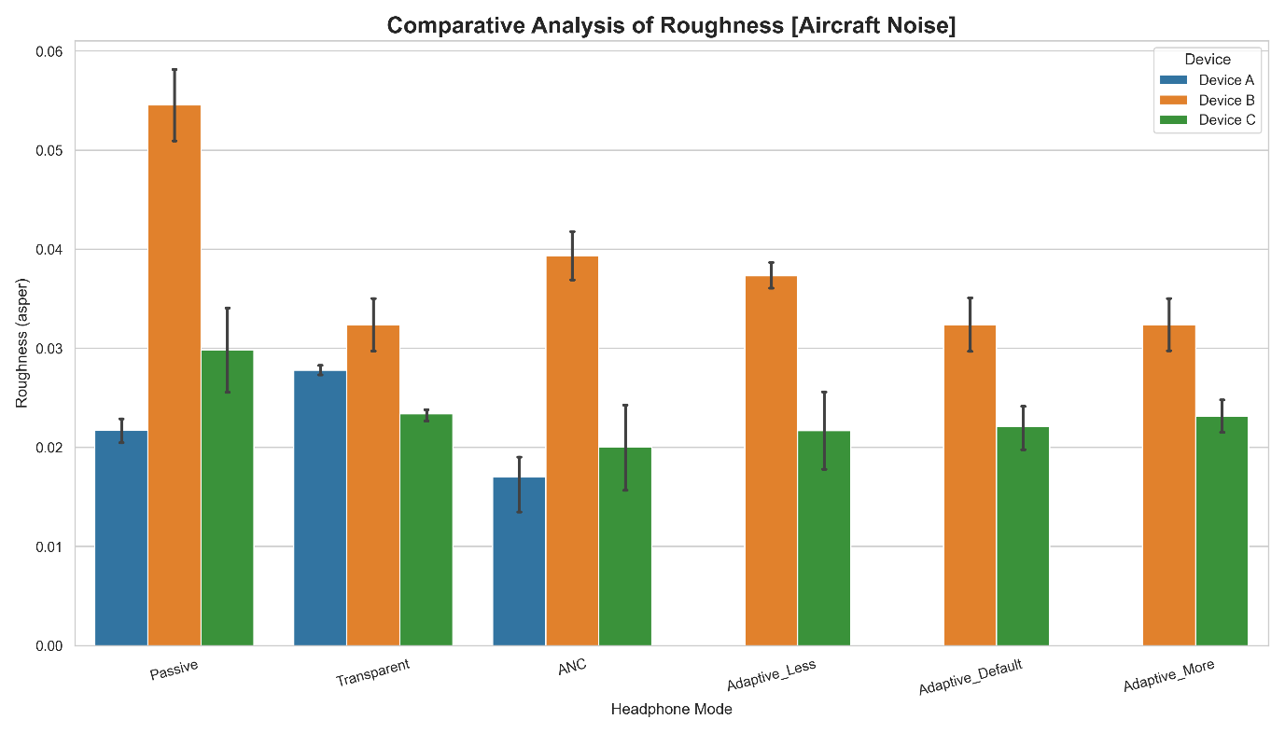

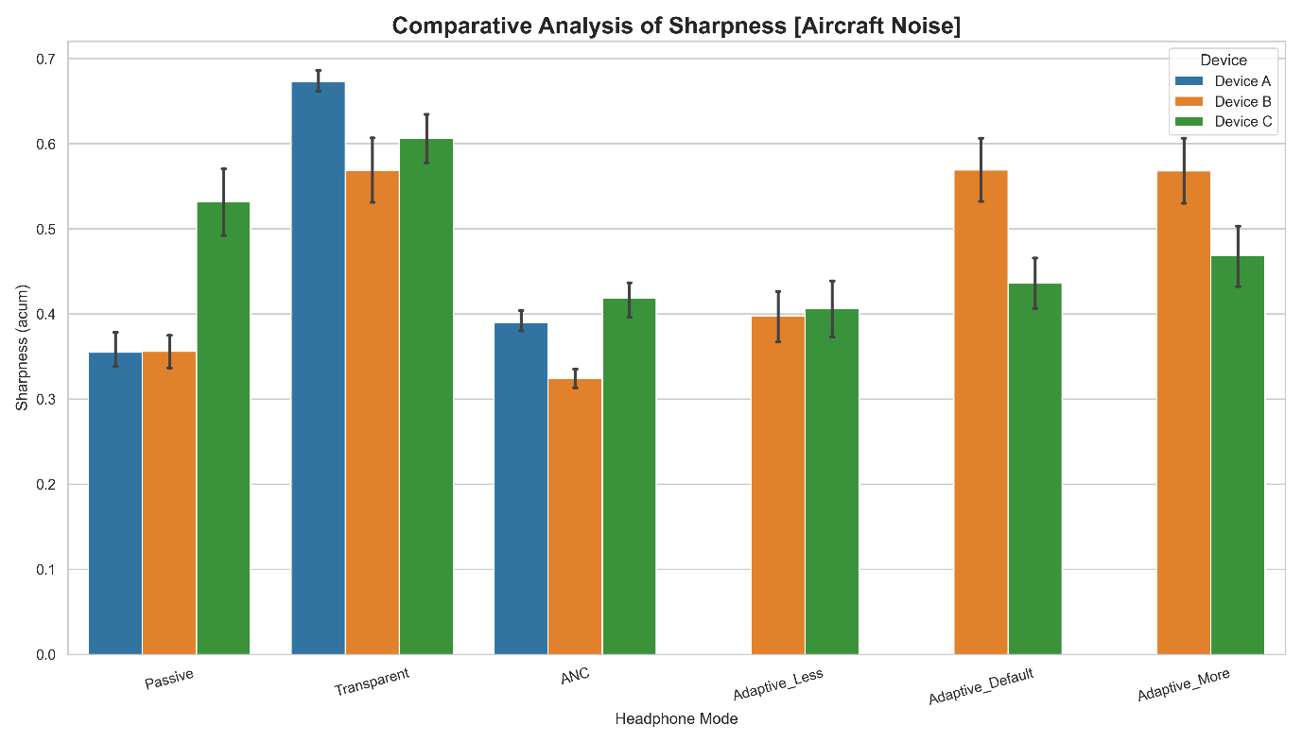

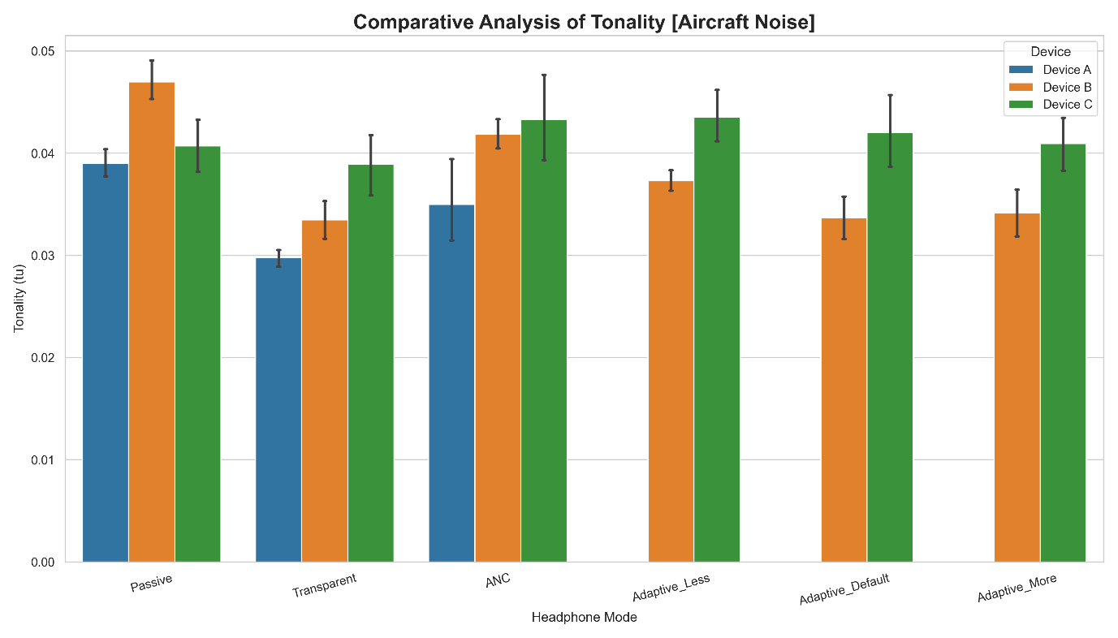

Pub Simulation Psychoacoustic

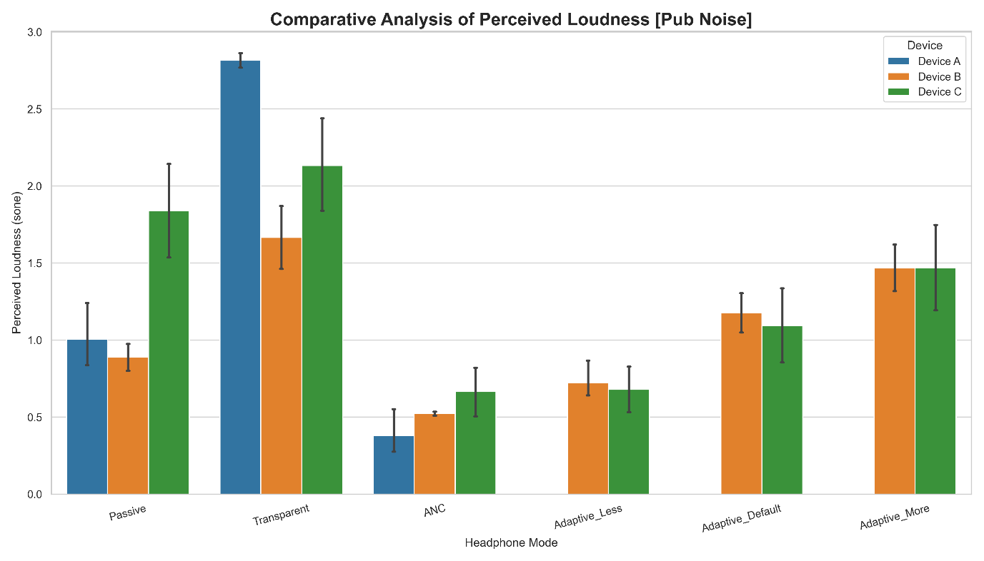

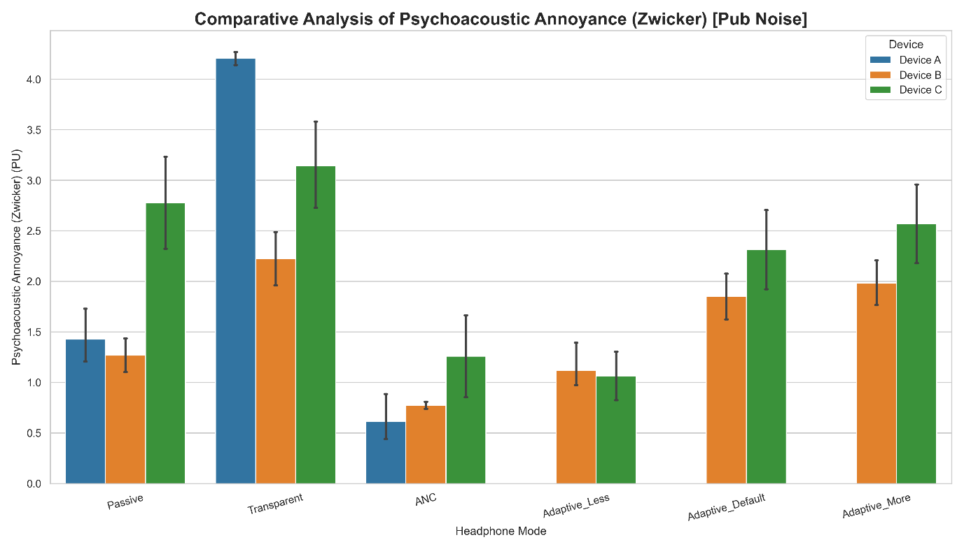

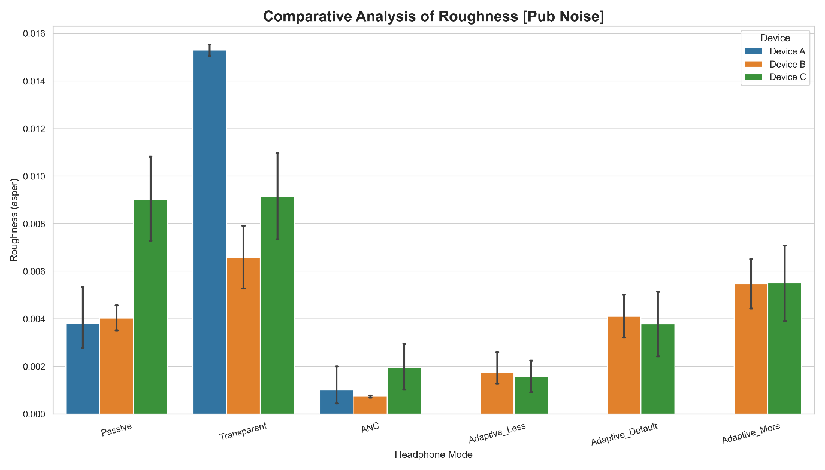

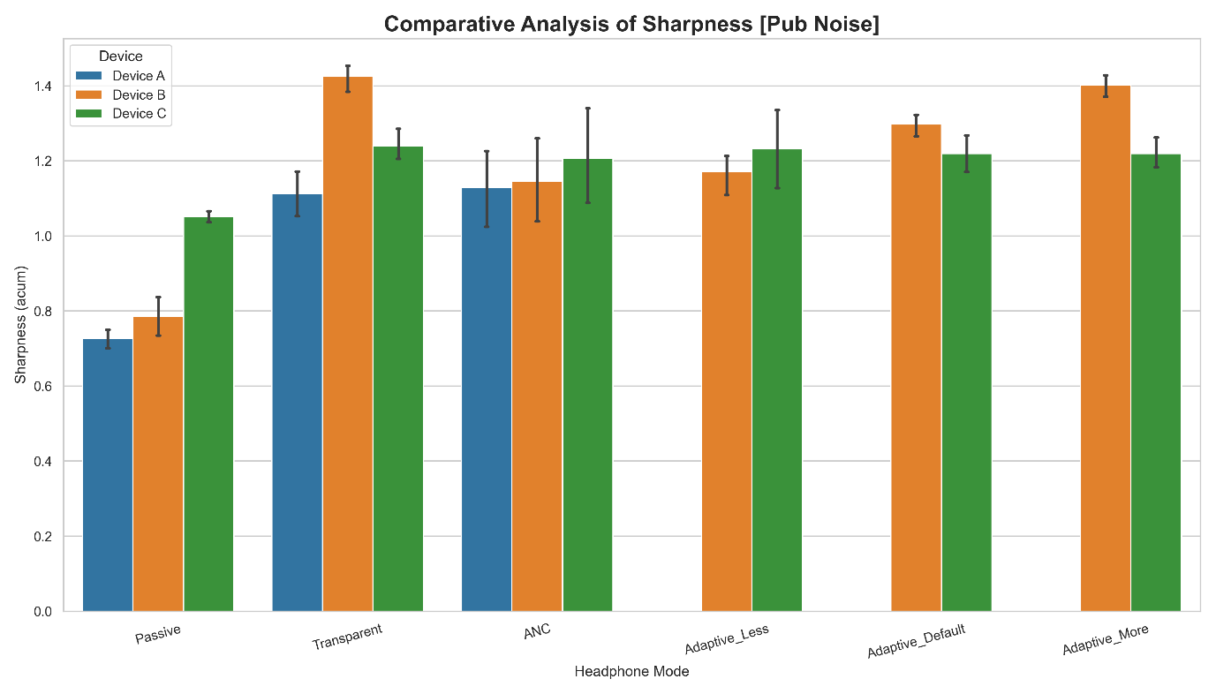

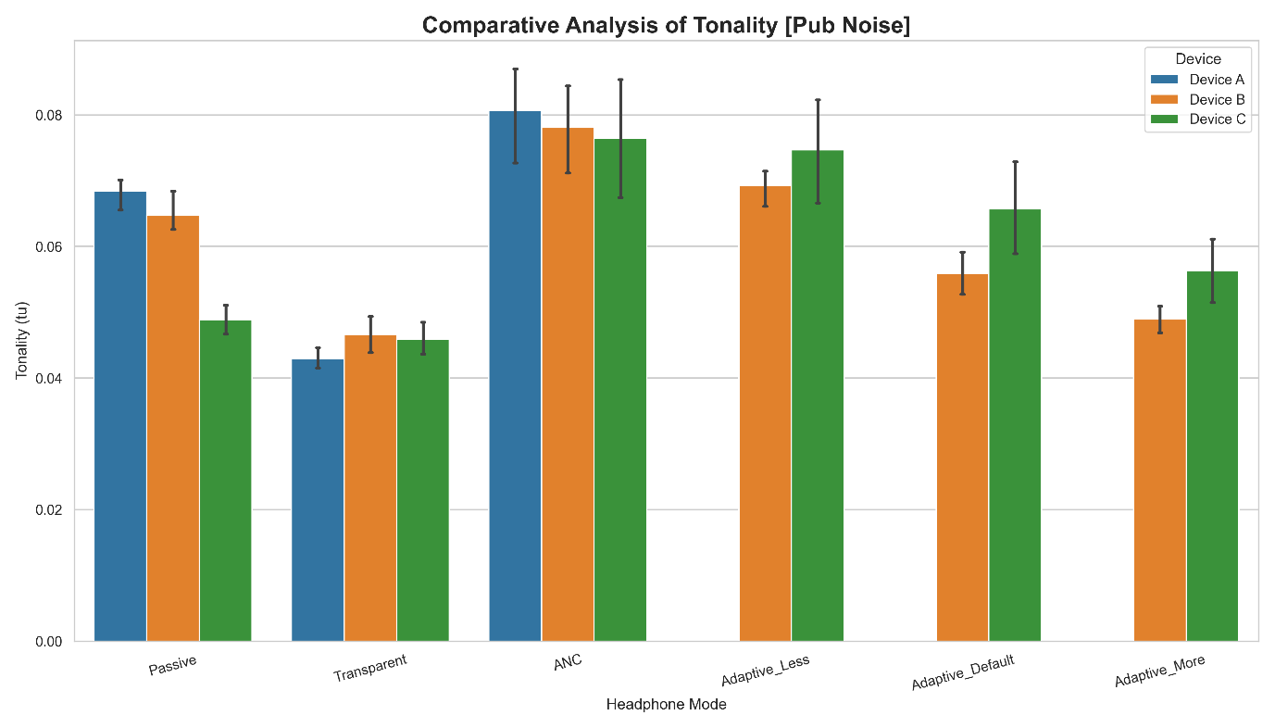

Pink Noise 60dBA Simulation Psychoacoustic

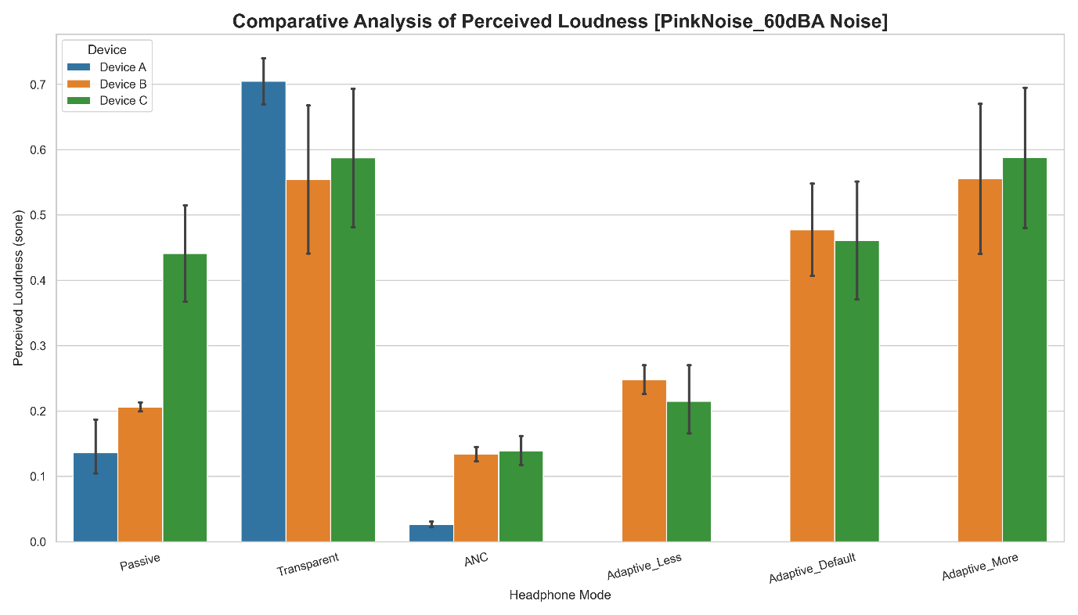

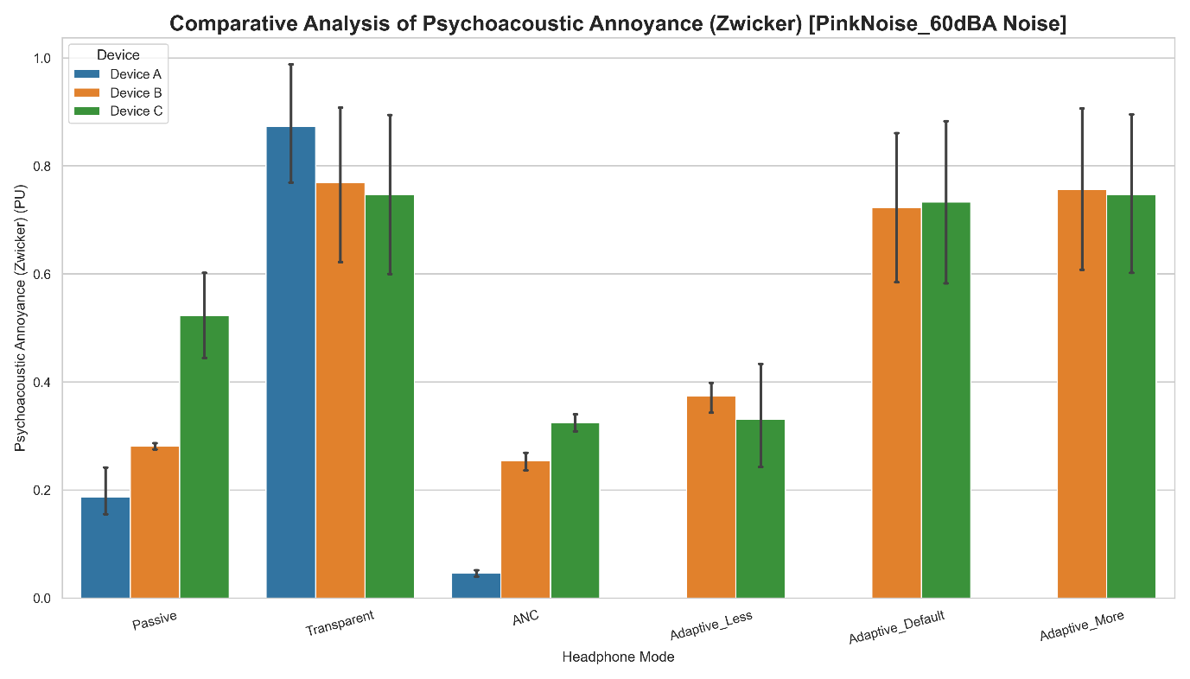

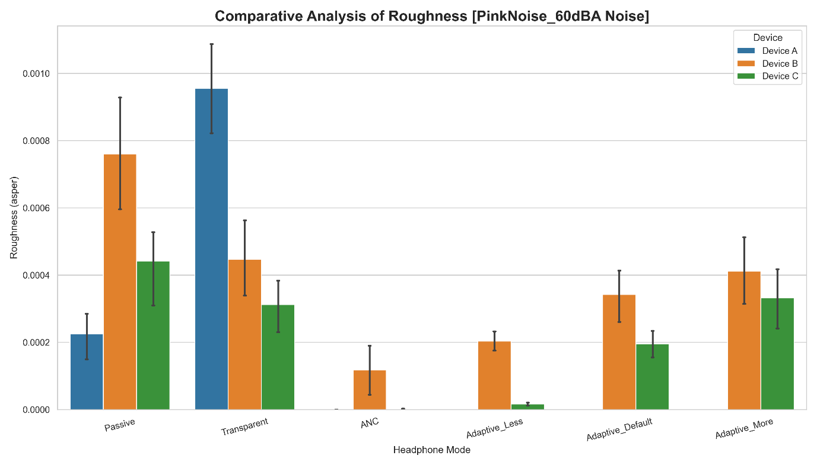

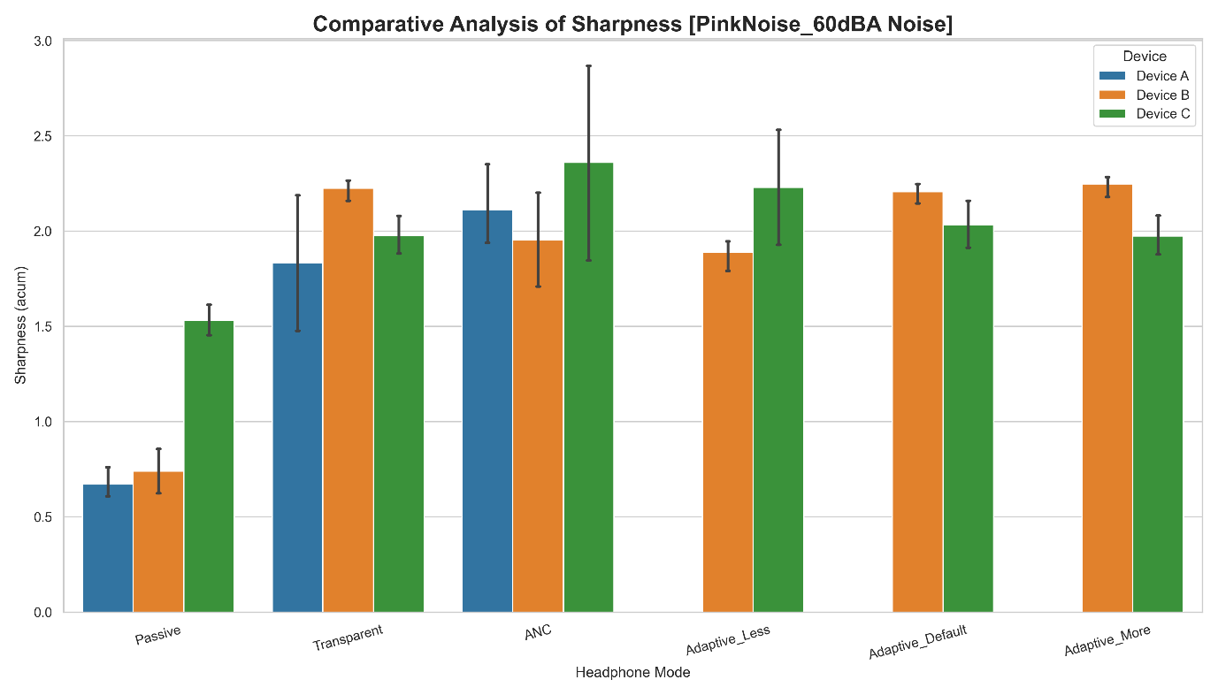

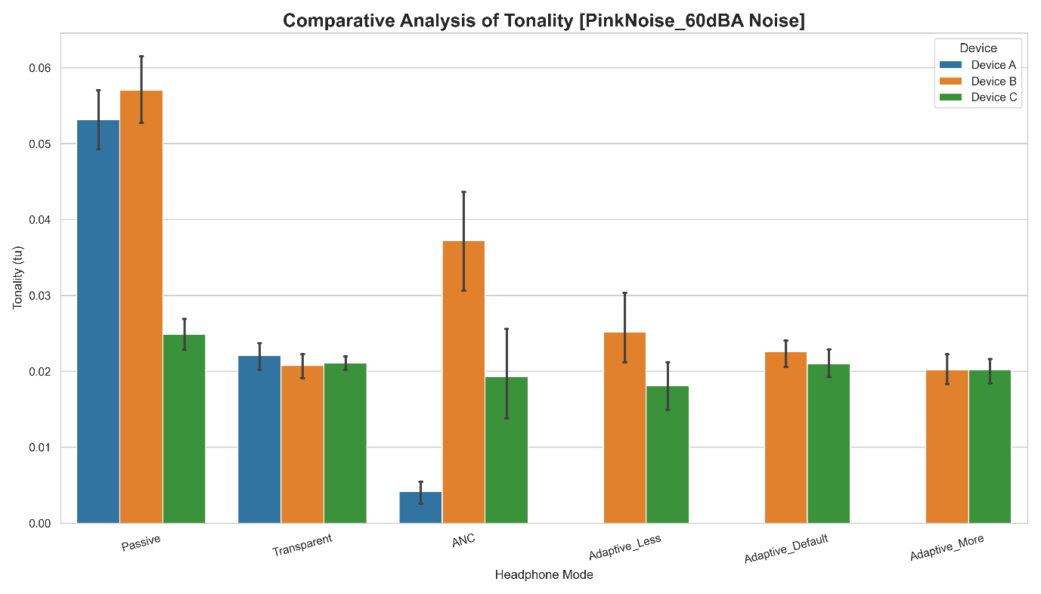

Pink Noise 70dBA Simulation Psychoacoustic

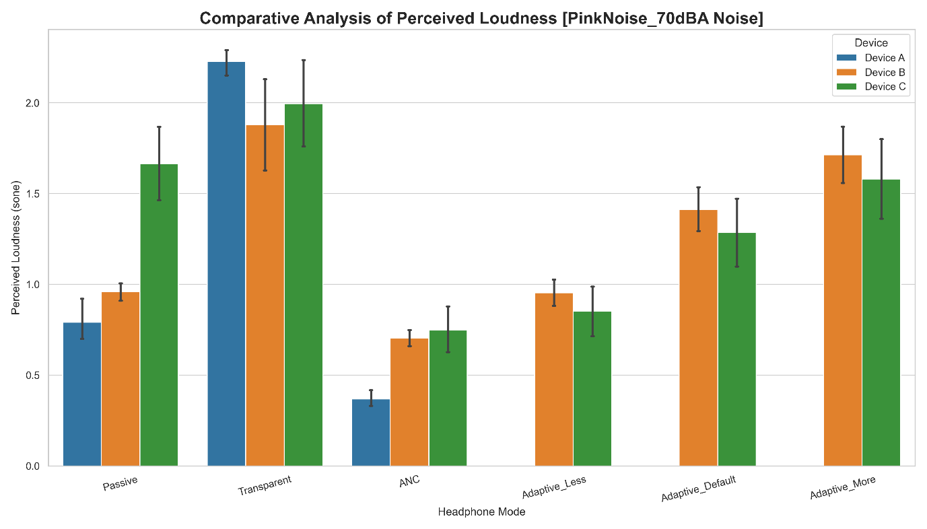

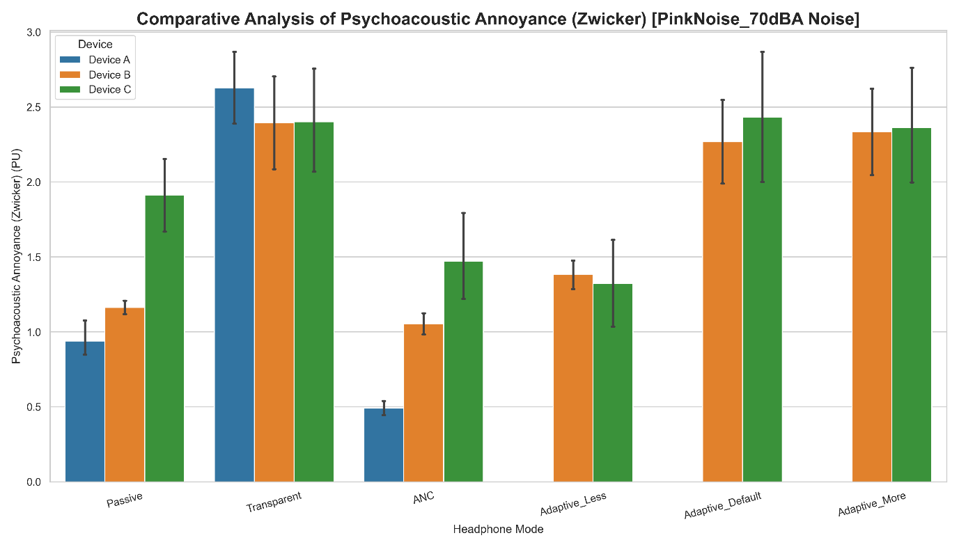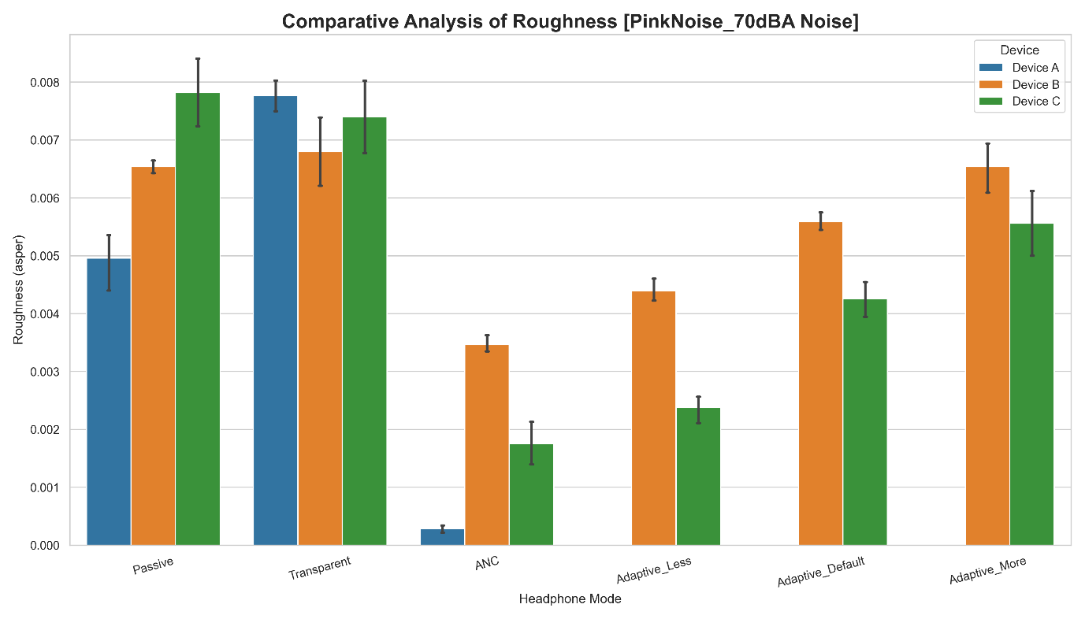

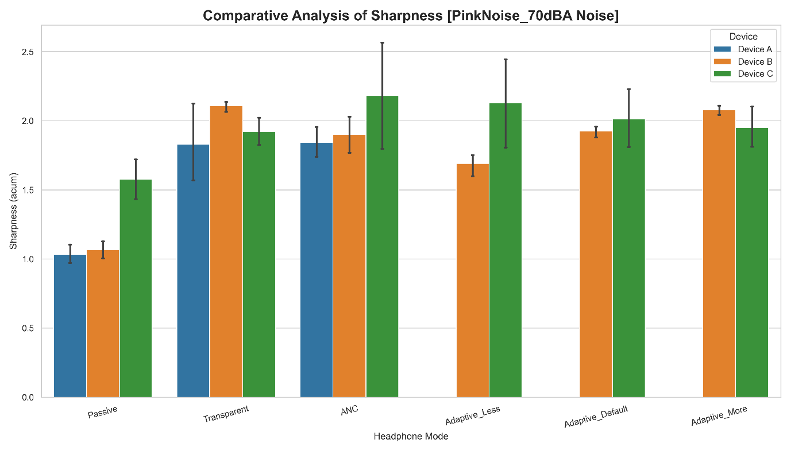

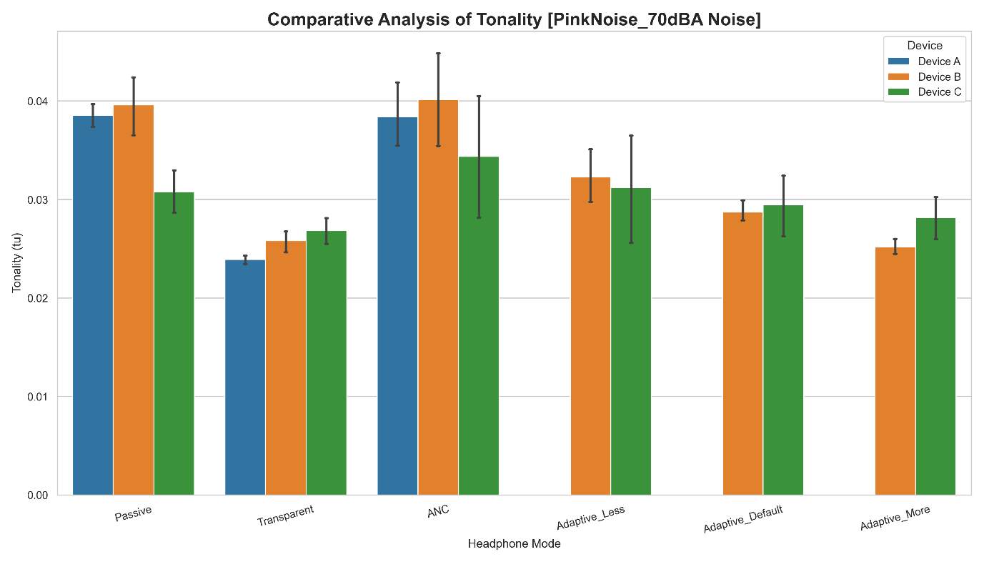

Pink Noise 80dBA Simulation Psychoacoustic

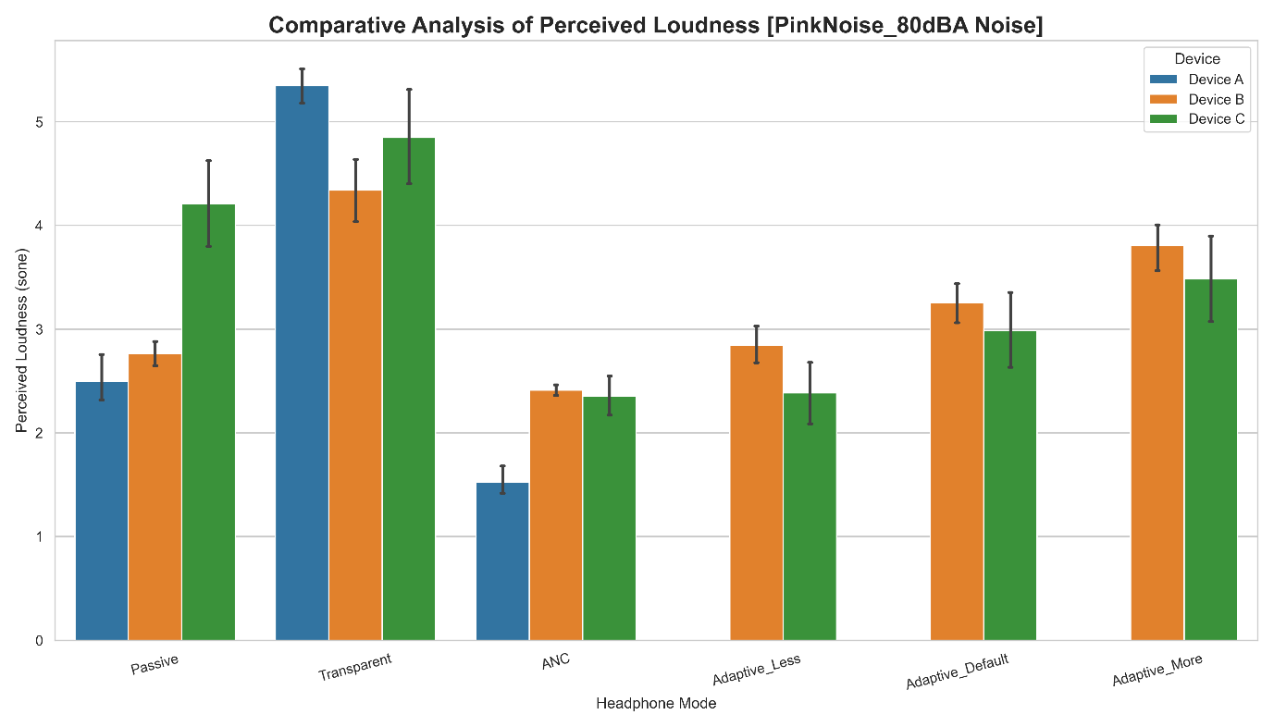

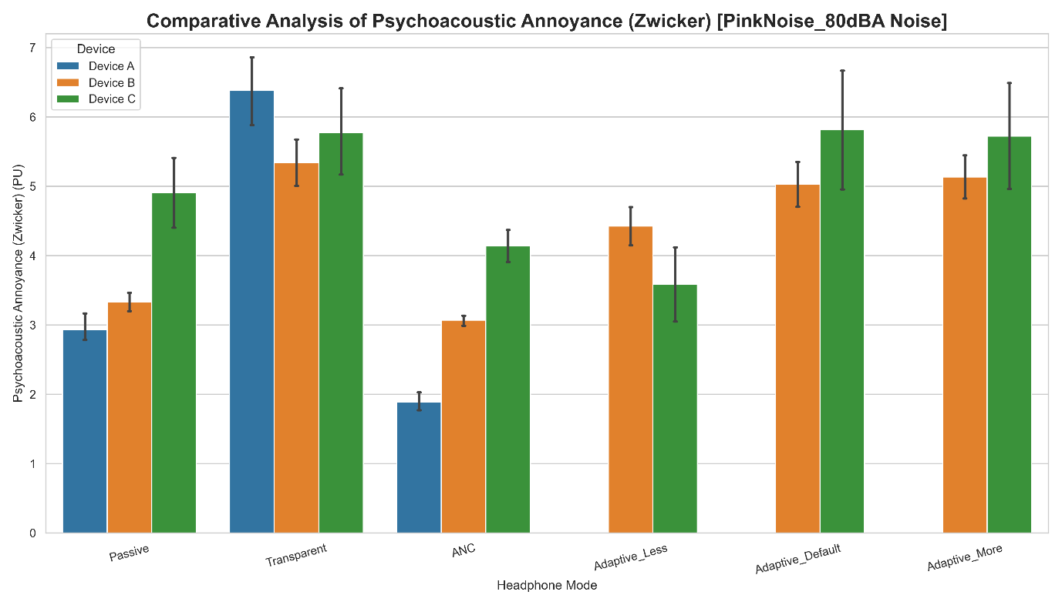

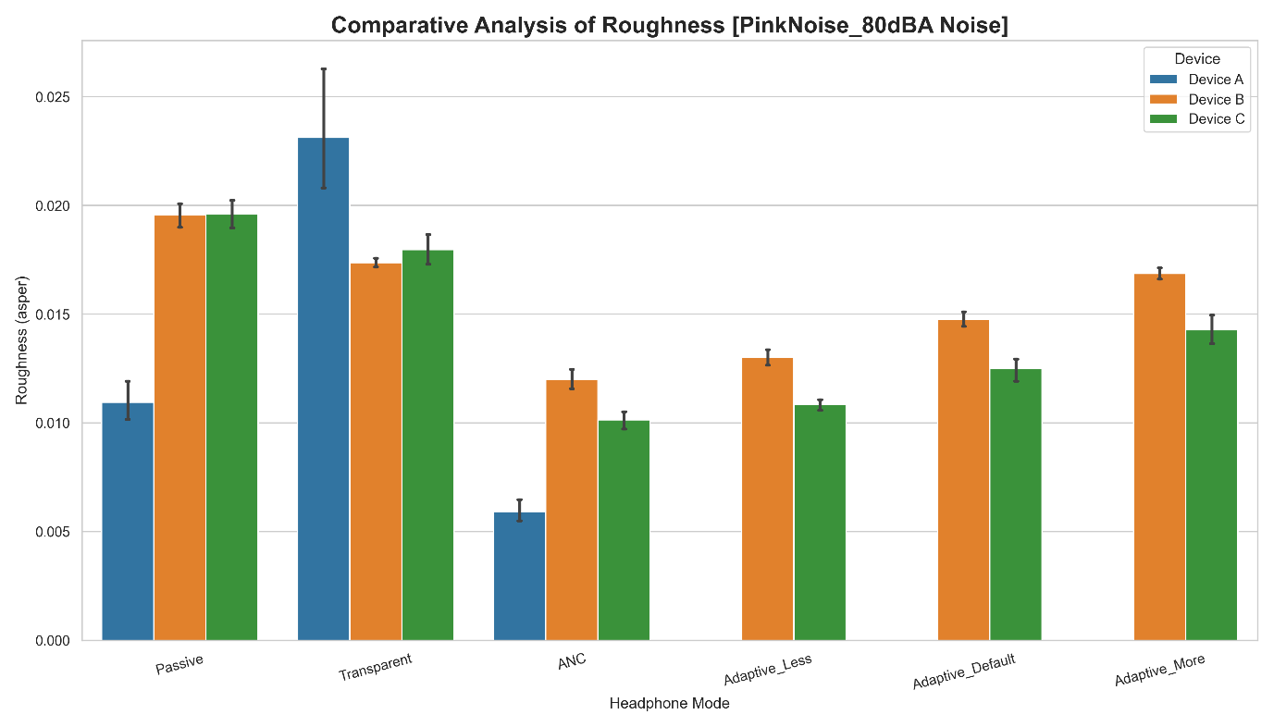

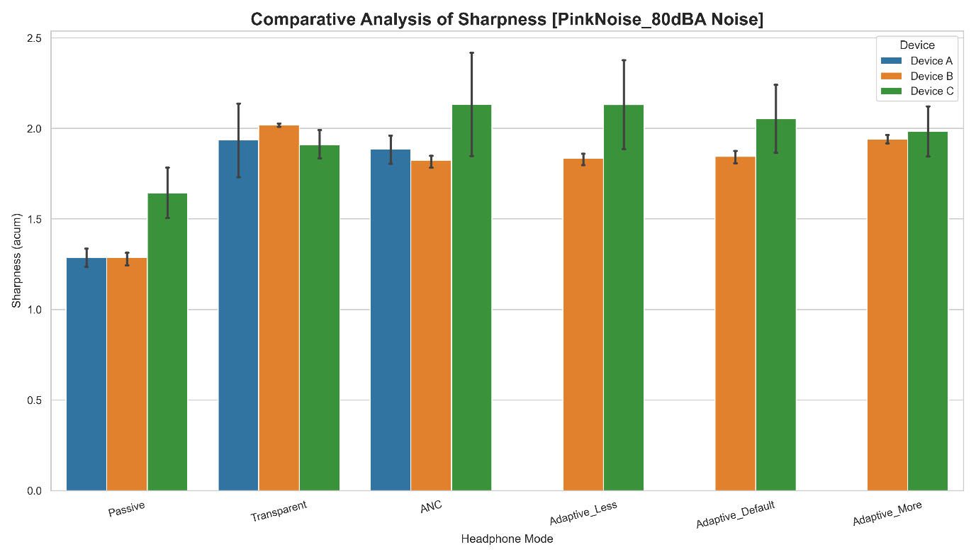

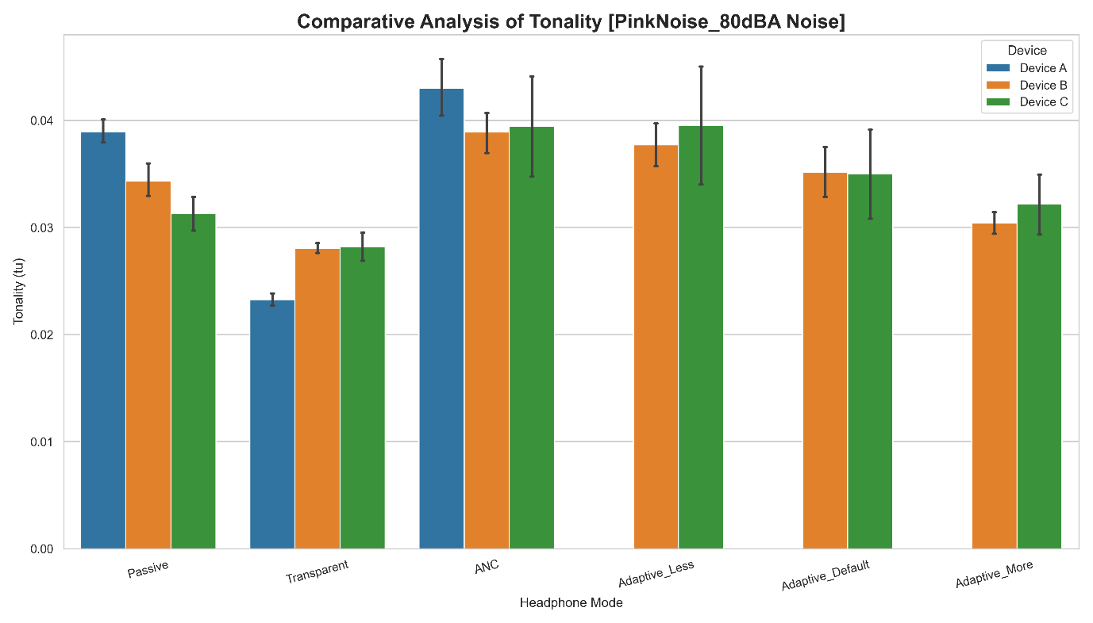

Pink Noise 90dBA Simulation Psychoacoustic

